Photo Competition Information and Entry Details

Photo categories
Category code | Category
A | Flora
B | Fauna
C | Landscape
D | Fire & Extreme Weather
E | Heritage, Culture & People
F | Marine & Coastal Environment
G | Odd Shots - photos that don’t fit the entry criteria (e.g. portrait, panorama) or a category (e.g. fungi)
Note: competition organisers may reallocate the category of your entry if appropriate

Entry criteria
Your photos must meet the following criteria to be eligible for the competition:
- Maximum 8 photos per entrant (1 entry form)
- Photos must be in a reserve, conservation area, or natural landscape in South Australia
- Photos of flora or fauna must be of a native species
- Photos must be in landscape format (except ‘odd shots’ category)
- .raw image files not accepted, all other files accepted (e.g. .jpg)
- Maximum file size 5MB
- Minimum image resolution of 3510 x 2490 pixels/camera needs to be at least 8 megapixels. (see below for details on how to check image size and camera capabilities).

How to enter
- Read the entry criteria above
- Select your photos and fill out the entry form (attached to the competition email). Make sure to give your photo a name, location and describe any other information about the photo. Save the entry form in a folder on your computer.
- Save your selected photos in a folder on your computer with this naming convention:
Category code/Photo number/Entrant name e.g. B2AmandaDudgeon.jpg
Category code = as per category list
Photo number = the number of the photo as per the section on the entry form
Entrant name = First name Surname
- Upload your photos to our Dropbox folder (see detailed instructions below)
- Email your entry form to DEW.SARangerAssociation@sa.gov.au before the due date and you’re done!

Dropbox instructions
1. Ensure all photo files fit correct sizing in the ‘Entry criteria’ and are saved and named on your computer using the convention provided in ‘How to enter’
2. Click the Dropbox link - you may need to copy and paste the address into your browser https://www.dropbox.com/request/gnJOWkFXzF4TFm6hGipa
3. Select ‘Add Files’ and ‘Files from Computer’
4. When window opens choose your first photo file. The file name will appear on the page showing it is ready to upload
5. Click the "+ Add another file" to select the rest of your photos ready to submit
6. When you have selected all the files you wish to upload click "Upload"
7. If you accidentally select upload before you've selected all your files just click "Submit more files" when your photos have finished uploading
8. You can repeat the process for more photos at any time up until the close of the competition

Image size explained
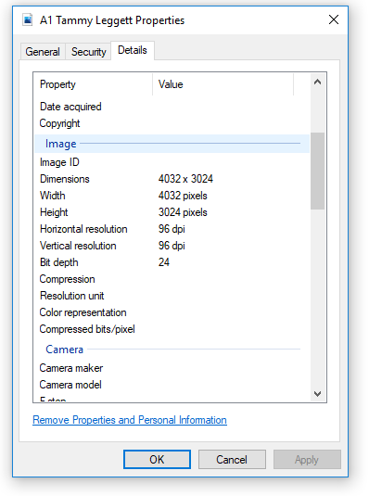
In order to have print quality photos, your image should be of a certain minimum resolution. Our recommended minimum resolution is 3510 x 2490 pixels which is the standard dimensions of an 8 Megapixel cameras photos.
Don’t know your camera’s megapixels? Please Google your model.
Don’t know how to check your image resolution? On your computer:
Right click on your image and select ‘Properties’, then select the ‘Details’ tab.
Scroll down to ‘Image’ and ‘Dimensions’ to see what resolution your photo is.

